**TAIRUA GOLF AND COUNTRY CLUB (INC)**

**Board Meeting**

**Tuesday 23 July 2024 at 4.00 pm, Clubhouse**

**Minutes**

1. **Present:** Ken Edwards, John Fraser, Jan Stanley, Jean McCann, Brian Fellowes, Riki Tawa
2. As Secretary: Jean McCann
3. **Apologies:** Steven Fang, Michelle McLean
4. **Minutes of the Previous Meeting (attached) P**roposed Ken, Seconded Brian.
5. **Matters Arising:** Tee flags installed.
6. **Correspondence**

**IN:**  **Azimuth Proposal**

John gave a summary of events which led to an advantageous outcome for the TGCC in terms of drainage and works done by developers on the Golf Course.

Proposal was submitted to the Board. Proposed Ken Seconded John All in favour.

President to sign on behalf of the Board. File with all Azimuths dealings to be compiled for future reference.

**OUT:**  **-**

1. **Finance**

* **Reports received:** Membership, Actual against Budget
* **Discussion of Club’s short and long term finances.** Up on Budget. $120 000 excluding GST brought in by green fees. Firewood while not showing a profit due to lack of wood for sale is near to last year’s income.

A Club Luggage trailer at $3000 cost with $2000 donation bought which will be beneficial for tournaments. Notification in Newsletter. (Paul to action)

Progress being made on Practice Nets with all materials delivered at a cost of $9000 against quotes of $50000.

* **Approval of Payments**
* **Westpac Board Signatures** Board need to sign to facilitate Card and Term deposit for TGCC.

That Finances be accepted Proposed Ken Seconded Riki. All in favour.

1. **Reports to be confirmed**.
2. **Membership**

Bryan Millington – Country Affiliated

Gary Conway – First Year

Caitlin Simons – First Year

Tim Simons – Full Golf

**New members to be confirmed.**

1. **PR and Marketing**

* **Newsletter**

Paul requested photos to add to the Newsletter.

Paul proposed a newsletter for the Public, highlighting events. To be circulated on Facebook Chit Chat.

* Information Centre now is promoting Golf Club on TV and Paul will produce a flyer for stand.
* Suggested that Business House needs more publicity to local Businesses (Jan)

1. **Staffing – Ken**

* **Staff activities in Club Time - Club regripping**

After discussion that the service was of benefit to the Club a Proposal was put forward that Paul is to continue, providing he manages his time, so it does not interfere with Club duties.

Proposed Jean Seconded Ken All in favour.

* **Report from Paul as to his trial period as Club Manger with suggestions.**

Paul discussed his experience as Club Manager and is happy to continue in the post. He feels his job description is accurate and does not need changing before his review.

Paul excused himself from meeting.

* **Discussion by Board re permanent position appointment.**

Board discussed Paul’s strengths and weaknesses and it was proposed that Paul be appointed in a permanent capacity as Club Manager. Unanimous agreement. Ken and TK to ensure formal letter of offer is correctly worded with length of employment clearly stated.

1. **General Business**

* Ken raised issue that before the AGM in October the golf captains need to hold golf meetings to elect the 24/25 Golf Captains.
* Discussion re long standing members and loyal volunteers leaving Club need recognition. Tina and Arthur Larsen leaving November would have farewell function organised by Club. Ken to talk to Tina re dates in October/November.
* Also need to acknowledge Bob and Marilyn Mcabe who were leaving Tairua shortly.
* Suggested that plaques be made to acknowledge long service to the Club.
* Brian reported that Ladies wanted to plant shrubs between Fairways 5 and 8.
* Brian to authorise location of planting, taking into account mowing requirements.

**Meeting closed at 5.01 pm.**

**Next meeting: 20 August at 4 pm.**

**President’s Report**

We are now officially at the “there is nothing happening” stage of the year with winter well and truly upon us.

The Netball girls are continuing to produce great meals at very affordable cost for our “first Friday” evenings, thank you to all that continue to come along and support them. July the lucky (or unlucky) Steve Tee had his name come out for the members draw, good news for the rest of us he was not in the clubhouse to claim $300. August 2nd $350 will be up for grabs so come along have a drink and be in the clubhouse when your name comes out.

We continue to get first time visitors to our course and every one of them are very pleasantly surprised, with the promise of we will be back. A lot of this comes down to the efforts of our greenkeepers Geoff and Alex along with the loyal but these days sparse volunteers.

Welcome back to all the lucky people who fled our winter for holidays in warmer places. Keep warm Summer is just around the corner.

**Ken**

**Course Convenor Report**

Winter weather has hindered our ability to play golf, but our course has, so far weathered the elements. The drains we have made and continue to make have helped to minimise the water on our course.

The bridge at the SE side of 4 green has been rowed back to its normal position by Geoff and replaced on loose concrete to ensure it does not float away again. A new shelter has been erected by 8 men’s tee for the protection of the ladies. The tin fence on the south side of the bowling green has been removed and a line of shrubs planted to ensure people do not drive forward into the drain.

The volunteers have been doing regular cleanups around the course and in the gardens.

**Brian Fellows**

**Course Convenor**

**Men’s Golf Report**

Here's some results from various scrambles held this month.

On Thursday the 4th of July with a field of 11 players:

1st place Rick Mclean 40 stableford points

2nd place Warick Rogers 38 points

3rd place Robyn Hayward 37 points

Saturday the 6th of July:

1st place Kath Hale 39 stableford points

2nd Warick Rogers 38 points

3rd Fred Watts 35 points

Thursday the 11th of July we had the pleasure of the nine hole ladies joining us on the course. The ladies started t 12:30pm and this worked well with them slotting in behind the last of the 18 hole players. A field of 17 eighteen hole players and 11 nine hole players was great to see in the middle of winter.

1st place in the hole scramble was:

Brian Cole 39 stableford points

2nd place Warick Rogers 37 points

3rd place Leon Smith 36 points

The ladies 9 hole scramble results were:

1st place Robyn Hunter 21 stableford points

2nd place Carolyn Williams 19 points

3rd place Anna McGure 19 points

Saturday the 13th of July saw a field of 19 players on the course

1st place: Ross Reid 38 stableford points

2nd place Fletcher Koot 37 points

3rd place Mark Corywright 34 points

Thursday the 18th of July saw 8 brave souls on a cold, windy day. Winners on the day were:

1st place Ray Russel 37 stableford points

2nd place Rik Tawa 36 points

3rd place Mike McCann 33 points

Saturday 20th of July saw the dredded sign out that said 'course closed.' When we are able to play the course has been in great condition and scoring has been good, shown in the results above. Thanks to our marvellous team of workers who continue to keep our course in top condition. Congratulations to Warick Rogers in winning the Malcolm Hume Trophy, had the best aggregate nett score over 2 rounds of 146, 4 points clear of the nearest rival Mark Corywright. Warwicks scores were - Round 1: 66 nett and Round 2: 77 net.

Until next time, better golfing everyone!

**JULY LADIES’ GOLF REPORT**

We are now in the middle of Winter, and we must expect the rain and the wind. However, we have had some good turnouts at the beginning of the month, and we opted to play on Thursday 11 July at 12.30pm as the weather was excellent during the week. This was very successful as we were able to join the 18 Hole players after our golf in the clubrooms. We will continue to do this when the whole course is open. The later time suited many of our players.

On Monday 5 August a team of 18 Hole players (Linda Keyte, Robyn Hayward, Jan Collier) and a team of 9 Hole players (Sue McDonnell, Carolyn Williams, Jenny Cosford) are travelling to Tauranga Golf Club to represent us in the Dorothy McNicol Tournament. We wish them luck.

There are tournaments coming up at Paeroa and Williamson-Whangamata so we would like a few of our players to support them.

Looking forward to August where the days are becoming longer and the nights shorter.

**Jan Stanley**

**Ladies Golf Captain**

**Golf Croquet report**

It has been a bit of a mixed bag this month, with numbers slightly lower and a few rained off days.

W had the most amazing weather conditions a couple of weeks ago, brilliant blue skies and little wind, with full courts including this little Piwakawaka ( Fantail) who followed us around for all 3 games narrowly missing the ball on several occasions. What an absolute delight, we could have watched him all day. 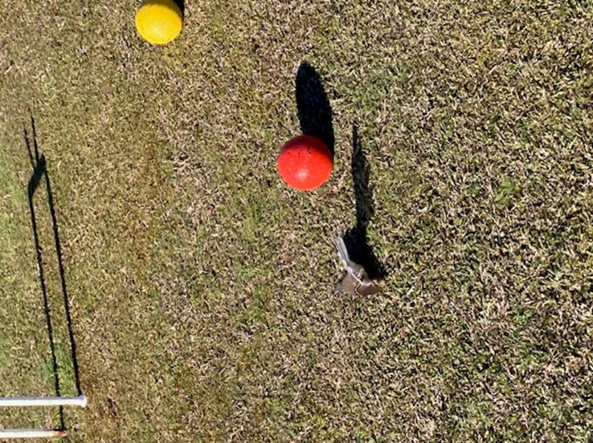

As usual thanks to everyone who help to make our club days happen.

Michelle McLean

Golf croquet captain.