**“THE CLUBHOUSE NEWS”**

**Volume 1/2020**

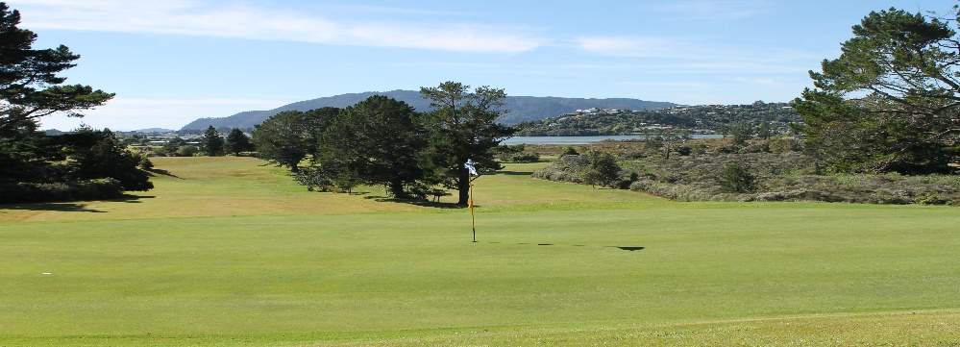

**Golf Trivia**

**Modern golf was popularized in around the 15th century, in which country?**

***In this issue***

* Golf Trivia Questions
* From the President
* From the Club Manager
* Upcoming events
* Rules
* Tips on playing hole 2

**From the President**

It’s been interesting living where we can see the comings and goings at the club, look out over several greens and be aware of the level of usage!!

Having the front office attended over the peak of the holiday season meant we did well with the collection of green fees, hiring out carts, clubs, trundlers and signing up new members; shop, bar and kitchen sales added to this. Well done all of us – great to have lots of volunteers help spread the workload, ensuring the club maximises its opportunities. A special mention to Graham, our man on the spot.

Geoff and his team have kept the course looking and playing well, despite the challenges of the hot dry weather. The Clubhouse and gardens are looking very smart indeed and contribute enormously to the friendly, welcoming club that Tairua is. Great to see the overnight campervan use of our land especially by those who are golfers– any way of making an income off our land has got to be worth exploring.

Co-opting a new Board member remains a work in progress. While it’s not a problem for the Board to operate with one less member, ensuring we have a quorum (not less than five) for meetings could become a problem.

The various working groups for running different areas of the club are getting underway. Thank you, Brian, for taking on the OSH role and identifying others to work with you on this. Work on revising the Constitution will get underway also. The hope of finding a caterer remains live and there are a couple of “feelers” out at present.

Jessie Birss, Club President

**Ken Edward’s resignation;**

The Board would like to acknowledge the work that Ken Edwards put into the club during his time as a Board member and as volunteer Bar Manager over recent years.

Ken remains an active member of the club and of our volunteer team. Hopefully he has more time to enjoy his golf!

Thank you, Ken

**Brag Site**

Are you one of the members asking what the Board achieve?

The members can be very proud of the achievements of the Club as listed below.

**Work Completed Since September 2019.**

* Reviewed and instigated a new subscription structure.
* Reviewed Green Fees against surrounding Courses. Instigated new rates.
* As above for Carts
* Fully implemented and integrated new Accounting System.
* Hosted AGM leading to several initiatives such as: - Full Constitution Review, Board Culture review, Committee reimplementation, Health & Safety review.
* Re-instigated House and Gardens team which has seen the Gardens looking fantastic, the painting of all outdoor furniture to one colour, the reinvigoration of our Foyer area painted from floor to ceiling.
* Solved a cooler break down with the kitchen volunteers loving the result and second-hand fridge.
* Created modern rolling electronic Honours Boards.
* Created a Course Guide to go into production.
* Revamped the stock and fridge (compliments of Coca Cola) in the golf shop.
* Updated all our hire equipment to maximise this return.
* Secured three new Tournament name Sponsors in Super Liquor, New World, Whangamata, VistaLite Aluminium. (Mike Koote) while retaining some existing ones.
* Restructured our Bar Rosters, added new ranges, reviewed licensing requirements. We have seen the return of many members eager and willing to help.
* Introduced a new range of Bar foods.
* Launched the new Website following the hacking of our old site.
* Brought on numerous new hole sponsors and new members.
* Initiated moves to reconnect with our local community which is progressing very well.
* Return to Tairua’s’ amazing club spirit and desire to work together for the club.

**This positions the club $68,983.00 better off than it was at this time last year.**

**From the President**

Welcome to the **first edition of the 2020 of the Club Newsletter**. This is the first issue under the new member of the Board Jean McCann. She is most receptive to any ideas/ photos/news from members as it is a newsletter written for members. Please contact her at Tairua Golf Club [info@tairuagolf.co.nz](mailto:info@tairuagolf.co.nz)

**From the Club Manager**

**The golf season** is due to open on Saturday 1std of February with a mixed scramble, Stableford, the Atkinson Shield and HelloWorld Travel Prize. We hope to have a good turnout.

9 Hole Golf starts on Tuesday 4 February, 8 a.m. for 8.30 start.

We have had a **great finish to 2019 and start to 2020**. The comment I keep hearing is just how good our course is. As members you should be proud of our course as I believe it is as good as any country course in the country and as good as many city courses both in its presentation and in the layout. The original designers did themselves proud when they finished carving the product, we enjoy today out of what was then, the wilderness. Amazing vision and for-thought.

* **Membership cards** are now available and now being issued to members.
* **For health & Safety reasons**, members are requested to report to the golf office (even if it is unattended) before going out onto the course. This way we know exactly how many rounds are being played on our course staff will be aware of players on the course. Since the office is closed most Sundays, Mondays as well as late afternoons, it is advisable that you inform a family member that you are going to play golf and give an approximate time you intend to be back. It is also advisable to carry a cell phone while on the course in case of emergency.
* It is great to see that members and visitors are making use of the **golf carts** available. Should you wish to hire a cart please book as there are only five carts. Bookings are recommended in advance especially for Sundays and Mondays when the office is closed.
* We have **volunteers** that help greens staff with course duties on Wednesdays (from 8.30am) and splits firewood on Tuesdays / Fridays (from 8.30am). If you are available to help on any of the days, please see Geoff Cambie (green keeper) or Bruce Crawford (course convener). Our firewood supplies are very short at the moment for several reasons however we have had 2 very good sources of timber made available to us this week. This should see us stock our sheds to the rafters and be ready for this winter.

For further information on any of the above membership options please contact the club manager on (07) 864 8416 or email [info@tairuacountryclub.co.nz](mailto:info@tairuacountryclub.co.nz)

* As usual **my thanks go again to all our amazing volunteers**. This has been highlighted by the call to arms for help with the bar. The response has been amazing with helpers offering their assistance left right and center.

It is so good to have you back and funny to watch those who have helped in the past “refresh their skills”. Without wanting to embarrass anyone (but I know Norm and Brian W are still laughing) I walked into the bar after giving the “boys” a brand-new bottle of Bacardi to replace the old one. I did hear a lot of noise which I ignored but when I went into the bar a little later, I looked up admire their work to see a “not full” bottle. I also noted a very clean floor and some sheepish looks. Apparently, the bottle resisted the attempts made to be placed on the dispenser. You can only laugh but lesson learnt. Hard to get good free help these days. 

* **Course Guide**. I have written a course guide complete with a 19th hole care of our patron Alan Wilson. (I get the feeling the 19th has been a place of great enjoyment for one of the original course builders. I am looking for a sponsor to put the guide into a booklet format to be made available for sale to locals and visitors alike. For $1,000 the sponsor will get the entire back A5 back page and a business logo on the front page
* **Golf Lessons –** A couple of members have had golf lessons and shown some improvement in their game. Should you be interested in a golf lesson, please contact Tony at the office.
* **Facebook:** Updates are posted from time to time on the clubs Facebook page. Please like the clubs Facebook page if you do have a Facebook account.
* **Order Firewood now! Be ready for the cold**



.

**Event Results**

It was very good December and January for competition golf.

The **Twilight series** saw 43 individuals play over the nights. First National were the sponsors with great Barker food packs for the top three. A big thank you to Darren for taking on 2020 twilight as well.

**Christmas open** sponsored for the first time by **Super Liquor Tairua** drew a field of 60 plus players in excellent conditions. A great prize table presented Christmas cheer of sponsors product was well received.

Christmas flew by and 27th saw us with 26 teams in the **Whangamata New World** 3 person Ambrose good number of visitors and clubbies combined to create a great day. Again, a groaning prize table with hams and vouchers. We look forward to working with Neville, Ricky and the team for many years to come. Awesome to see Tairua Surf Lifesaving being involved they are keen for next year as well.



**Winners:** Gary Jamieson (left), Brian Fellows (Centre), Rob Ford (right)

**Family Day** on the 3rd January was sponsored by local 4 Square saw 42 kids of various ages all go away with a prize all enjoyed.

**Tina Larsen, Captain**

**Golf croquet report January**

Our annual “Croquet Christmas fun day “was once again a success. We had 40 players, fine weather and a great day. Everyone later enjoyed a lovely lunch provided by Tina and her team.

Numbers have been strong over the holiday period with 14 additional non players coming one day to our club day. A big thankyou to our members who guided these players through the challenges of golf croquet. A really fun day was had by all.

Despite the dry weather the courts are in excellent condition, once again thanks to Rick and Brian for their continued hard work which is greatly appreciated by us all.

**Michelle McLean, Golf Croquet Captain.**

**Golf Brag Site**

**Hole in One’s for January**

**Ash Bennet** had his on the 2nd hole and got the shout and the trophy.

**Fiona Caldwell** got a hole in one on the 15th on the Family Fun Day.

**Congratulations**

**EVENT RESULTS**

**VistaLite Tairua Open** was held on the 10th of Jan a great event, great players, one off +0.9 excellent prizes and a full club rooms for prize giving.

None of the above could have happened without a great course, thanks Jeff and team and the countless volunteers that work so well to keep the club ticking.

**Bill Boon, Captain**

**Upcoming Events**



**Club Opening Day for Men & Women**

**Saturday 1st February**

Sponsored by **HELLOWORLD THAMES  
Members only travel voucher draw**

**must be present when voucher is drawn.  
18 and 9 Hole Stableford**

**9 Hole Players – 8.30am for 9am   
18 Hole Players - 10am for 10.30am  
$6 entry per person includes 2s**

**[  
Affiliated players only   
Members a plate for afternoon tea**

**Upcoming Events**



**The Guru of Grass --- Geoff**

A great summer for golfers who have been on the course in large numbers. Keeping water to the greens and tees during this great summer has presented its own set of challenges. Early on we had a lot of wind which actually blew the water away from some areas leading to several dry spots requiring flooding the green (taking a water tank to the green and opening the valve to let the lot cover the green) or hand watering dry spots. This was followed by very hot days with a similar effect on the grass. It is possible to counter some of this with wetting agents which help the water to stay where we want it.

All in all, the course is in great condition - the greens are rolling well given the stress they are under and need to be a little longer to avoid real damage.

My thanks to Darren and the mowing team for their help over the Christmas period. From the comments heard around the club house we are presenting a product we can be very proud of and that stands up very well against our surrounding courses.

Good golfing.  Please help us by repairing divots and as many pitch marks as you see on the greens.

All the Best …. Geoff and Team.

**Walk Tairua Article from the Tairua Advertiser Volume 20 N0 3**

Walkers on the Pepe Loop Track are still causing concern for the golfers where the track runs beside the golf course. "Walk Tairua" is keen to remind walkers on the Loop Track that they are on Country Club land at that point and must follow the safe-use signs and stick to the marked trail to avoid being hit by wayward balls and to avoid causing obstruction to golfers who have right-of-way. The Loop Track is a great asset for the town, as is the Country Club, so please respect the shared-use rules when using it. Thanks

**Adopt A Hole.**

Since I introduced this initiative a lot of water has flown under the bridge and communication has been on an as needed basis verses newsletters. I have not been able to secure sand buckets and our sand pile is due for replenishing.

We will re-launch this a little later in the year when I have sourced some small painters’ buckets for sand carriers.

Ball at rest moved accidentally on the Putting Green

During the WGC Match Play, Tyrrell Hatton of England was playing a sudden death play-off with two other professionals to determine who would represent group 10 in the knockout rounds. Although

the event is played as match play, any playoff with three or more players was conducted under stroke play.

On the first playoff hole, Tyrrell Hatton hit his approach to just outside 10 feet and had the upper hand on his two opponents. However, after missing his first putt and preparing to tap in his par, he accidentally moved his ball.

Luckily for Hatton, the tournament had a local rule in place that would allow him to replace his acci- dentally moved ball without penalty.

The referee walking with the group noticed Hatton stop before tapping in his par putt, exchange a few words with his opponents and then tap in his putt. he rushed over to find out what was going on and Hatton told him what had happened.

The referee informed him of the local rule and that the ball must be replaced on the spot from which it was accidentally moved. As Hatton did not replace the ball, he played his last stroke from a wrong place and has incurred a two stroke penalty. His score for the hole was now a double bogey six.

If a Committee or club wishes to introduce this Local Rule, the following wording is recommended: “Rules 18-2, 18-3 and 20-1 are modified as follows:

When a player’s ball lies on the putting green, there is no penalty if the ball or ball-marker is acci- dentally moved by the player, his partner, his opponent, or any of their caddies or equipment.

The moved ball or ball-marker must be replaced as provided in Rules 18-2, 18-3 and 20-1.

This Local Rule applies only when the player’s ball or ball-marker lies on the putting green and any movement is accidental.

Note: If it is determined that a player’s ball on the putting green was moved as a result of wind, water or some other natural cause such as the effects of gravity, the ball must be played as it lies from its new location. A ball-marker moved in such circumstances is replaced.”

**JOKE**

**The Voice from the Clubhouse**

It was a sunny Saturday morning, a little before 8 a.m., I was on the first hole at The Oaks of St. George Golf Club and beginning my pre-shot routine, when a piercing voice came over the clubhouse loudspeaker:

"Would the gentleman on the woman's tee back up to the men's tee please!"

I could feel every eye on the course looking at me. I was still deep in my routine, seemingly impervious to the interruption.

Again, the announcement: "Would the man on the woman's tee kindly back up to the men's tee."

I simply ignored the guy and kept concentrating, when once more, the voice yelled, "Would the man on the woman's tee back up to the men's tee. please?!?!"

I finally stopped, turned around, cupped my hands and shouted back: "Would the jerk with the microphone please keep quiet and let me play my second shot!"

**GOLF TRIVIA ANSWER**

Answer: Scotland

The origins of golf are somewhat unclear, though it is generally accepted that modern golf originated in Scotland. The first mention of it is in an edict signed by King James II of Scotland in 1457, prohibiting the sport, as it was deemed as a distraction from archery, which was at the time used for military training. The oldest golf club in the world is the Royal & Ancient Golf Club of St. Andrews in Scotland, established in 1754, and is considered the worldwide "Home of Golf".

**Rules Section: -**

**Not specifically rules but close.**

Many of you may have heard about the new World Golf Handicapping System scheduled to come into play in 2020.

The system is simply what the name suggests. Your handicap will follow you all over the world. However, there are a few other changes.

1. Only 8 of your past 20 scores will make your handicap. The 8 best so this will lower handicaps overall.
2. Your handicap index will change every day.
3. Net double bogey will be the max score you are allowed on any hole for handicap purposes.
4. PCC (when I learnt it was SCR) Standard course rating for many years ago returns to be called playing conditions calculation. The system will average the daily scores and call this weather effect and if everyone scores badly on a day the effect of a bad score will be less apparent on your handicap. (I personally believe this is rubbish but Hey …!) the old SCR system was much better.
5. Handicap will be adjusted for the difficulty of the course being played. Designed to allow for courses with many tee blocks which are ALL rated. Many courses now have 5 or more tee blocks and the idea here is to allow for one comp but many tee blocks. The idea is people playing the white and those playing the Black tees can compete evenly. (Nice concept which will lead to unhappy players everywhere -- dumbing down the game? Wishful thinking? Probably designed by someone who has never been on a low handicap. Good luck. It will stop me entering comp’s as I’d rather have a $ bet with my mates all playing off the Black tees. Time will tell.

**The Golf Shop.**

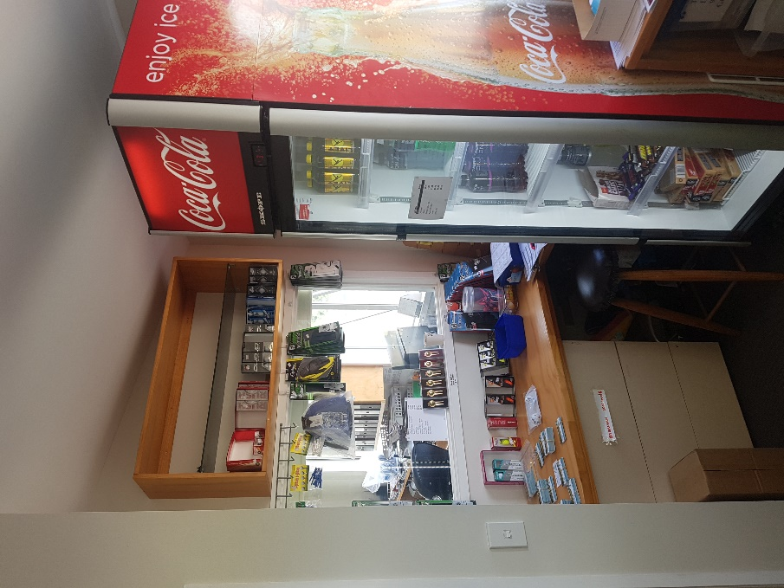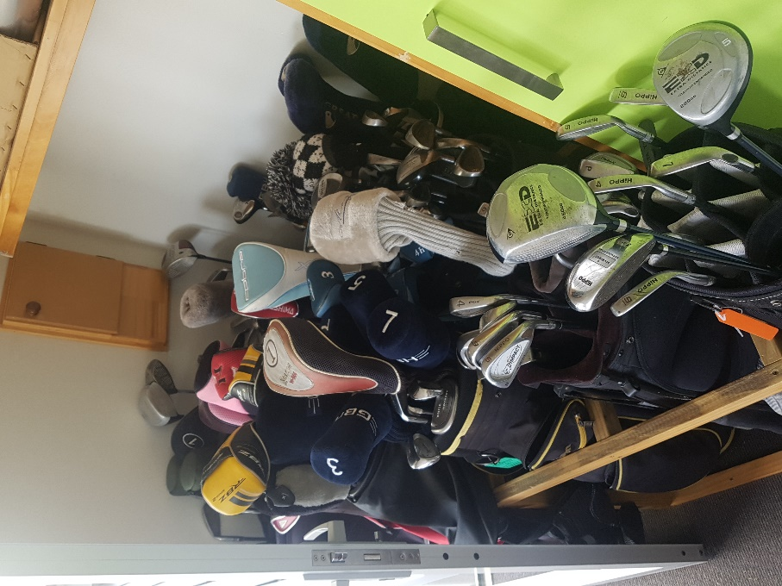

Just a reminder to everyone that whilst we have a very small shop incapable of handling shoes and clubs, I do have access to virtually every supplier. If you are looking to buy something try it, test it and price it wherever you are talk to me. I may well be able to provide a competitive price option.

From now until the end February I will special the SureShot GPS watch (see link) which has 35,000 pre-loaded course, water proof to 30mtrs and is a fitness tracker etc., etc. (These were the first prizes for the VistaLite Tournament)

<http://sureshotgps.com/product/watch-plus/>

The RRP. for these great items is $329.00. On sale here for $289.00.

The shop is better stocked now, and Coca Cola have provided a great fridge to keep our drinks cold and presented. A big thankyou again to those people who have donated equipment. Our rental gear is greatly improved.

Please note that some of the articles published are not always the views of club staff or management. We appreciate your feedback.